1. Description of the survey: (Text for Scientific rationale and Immediate objectives:
up to 3 pages. For Figures: 2 additional pages)

This is a public survey with KMOS
https://www.eso.org/sci/facilities/paranal/instruments/kmos/news.html

1.1 Scientific rationale:

Scientific rationale.
1.2 Immediate objective:

Immediate objective.

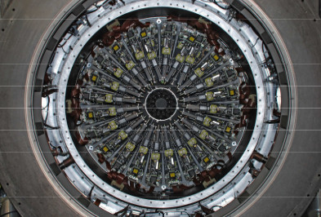
Figure 1: this is the figure caption.

- Are there ongoing or planned similar surveys? How will the proposed survey differ from those? (One page max for text and figures)

Are there ongoing or planned similar surveys? How will the proposed survey differ from those?

- Observing strategy: (text: 1 page max)

Observing strategy for visitor and service mode observations with KMOS
(https://www.eso.org/sci/observing/phase2/SMGuidelines.html)
Maximum of 20 arms and only in individual arm modes (no mosaic modes)

- Estimated observing time: (text up to 1 page)

Period | Requested time (hrs)  Including overheads | Exp. Time (hrs) | Mean RA or RA range | Moon | Seeing  (“) | Spectral bands | Transparency
P116 | 230 | 180 | 18 | Full | 0.6 -1.0 | H, K, H+K | Phot
P117* | 170 | 120 | 08-18 | Grey | 0.6 -1.0 | IZ, YJ | Clear
P118* | 230 | 160 | 08-18 | Full | 0.6 -1.0 | H, K, H+K | Phot
P119* | 230 | 150 | 08-18 | Grey | 0.6 -1.0 | IZ, YJ | Thin
Table 1: (*) yearly cycle

4.1 Time justification

5. Data management plan: (Up to 3 pages max, including text and figures)

5.1 Detailed responsibilities within the team

Detailed responsibilities of the team.

5.2 Data reduction plan

Data reduction plan.

5.3 Expected data products and deliverables

Expected data products: description of the added value with respect of the KMOS in-house products
(https://doi.eso.org/10.18727/archive/38) . Legacy value for the ESO science archive

5.4 General schedule of the project

General schedule of the project, including a timeline for the deliverables to the ESO science archive.

- Envisaged follow-up: (1 page max for text and figures)

Envisaged follow-up

